We divided the problem into 2 different cnn:

**architecture**

**image reconstruction:**

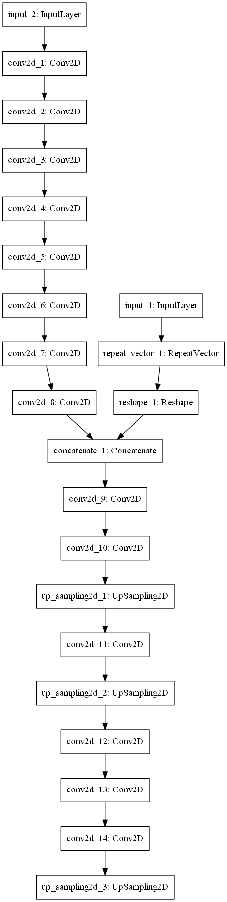

**Colorizing:**

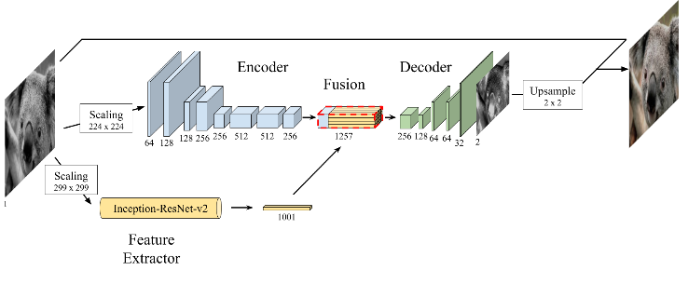

**Training:**

When we trained the net with a relatively small train set (40) and a high number of epochs we got the best results but the colors was not strong enough.

Result test



When we trained the net with a large (130) and more diverse training set we noticed that the images are painted in brown shades but the net was able to notice objects better.



As mention above ,adding the use of inception_resnet_v2 helped noticed the different objects and paint them in different colors

Without resnet with resnet with resnet



Our training loss was always between 0.025-0.03

**Hyperparameters**:

Optimizer= Adam

Loss function= mse